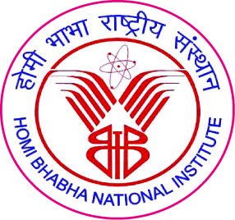
Homi Bhabha National Institute
Training School Complex, Anushaktinagar, Mumbai-400094

APPLICATION FOR OUTSTANDING M.Tech. STUDENT AWARD¹

I. Personal Details

Name of the Candidate:

Enrolment Number:

Name of the Constituent Institution:

Board of Study:

Present contact details with email and mobile number:

II. Details of M.Tech. program

Title of the Project:

Milestones:

Date of Enrolment:

Date of Submission of Project Report to Monitoring Committee:

Date of Final Viva-voce:

Date of Declaration of Result:
- Number of Annual Progress Review Reports Submitted:
- Number of extensions taken beyond normal period:
- Awards based on the research work reported in the project report (if any):

¹ (a) Students, whose Results have been declared during the period 1st January 2023 to 31st December 2023, are eligible to participate. This information of date of result declaration is available in Provisional Degree Certificate.
(b) Completed application form along with all enclosures should be submitted as a single consolidated pdf file. The name of the file should be ‘Surname_Enrolment Number.pdf’
(c) The pdf file should be sent to award@hbni.ac.in as an email attachment on or before 8th April 2024

III. Details of publications arising out of project work:
- Publications which are listed in the project report:
No. | Title of the Paper | Journal/Conference Title | Date of Submission of manuscript to the editor | Publication details  (Page no./ Vol No./ Year), etc. | Impact factor (if applicable)
..

- Publications which appeared within six months after the date of final viva voce:
No. | Title of the Paper | Journal/Conference Title | Date of Submission of manuscript to the editor | Publication details  (Page no./ Vol No./ Year), etc. | Impact factor (if applicable)
..

IV. Any other information in support of award: (enclose a separate annexure)

V. Enclosures:
- Training School marksheet
- Highlights of the project work (Maximum one page)
- Impact of project work (max half-page for each of the following attribute whichever applicable)
  - Contribution to the development of a new theory/product/ process
  - Relevance of project work with respect to DAE’s mission programs
  - Societal Impact

It is certified that information provided above by the student is correct to the best of my knowledge.

Date and Place: Signature, name and academic title as per footnote2

To:
Prof. B.K. Dutta
Convener, HBNI Award Committee-2022
Email: award@hbni.ac.in

2 To be nominated by Guide/ Co-Guide/ Chairman or Any member of Monitoring Committee/ Concerned Dean (Academic)/ Director of CI/OCC

